**Unit 5 Project Sample:**

**ELK Web Design Site**

**Step 1: Define Audience / Tone**

* Who will visit your site? Potential employers? New clients or customers?

This website is to teach beginners to become a grinder to make some money playing poker.

* What can make you and/or your product stand out against your competitors?

There are not a lot of website that teaches beginners about low limit Omaha 8. They have a lot of information on the homepage that overwhelms clients.

* How would you speak to your clientele if you were communicating in person? How could you translate that style and tone digitally?

I would be patience and use simple terms to ease clients in the process. The homepage will be simple and has many links in order so beginners can follow them.

* What colors represent you or your product?

Green and yellow like a poker table

* What images illustrate your message?

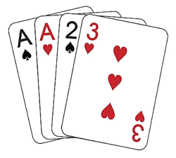

**Step 2: Define Site Structure**

What are the three-to-five pages titled?

Starting hands, Pre-flop, Flop, Turn, River

What will be the purpose for each? What should each page contain? Will there be textual content? Or just images?

**Homepage**

Purpose: to introduce playing Omaha 8 for a living and how to use the website.

Contain:

* + Heading: a picture and a title; also a link to go back to the homepage
  + Navigation: starting hands, pre-flop, flop, turn, river
  + Content
  + Contact information

**Starting hands**

Purpose: guideline of starting hands

Contain:

* + Heading: same with Homepage
  + Navigation: premium, speculative, flawed, junk
  + Content
  + Contact information

**Pre-flop**

Purpose: what to do pre-flop

Contain:

* + Heading: same with Homepage
  + Navigation: position, check-raise, set-mining
  + Content
  + Contact information